HTML and CSS Crash Course

<https://www.youtube.com/watch?v=qz0aGYrrlhU&ab_channel=ProgrammingwithMosh>

Frameworks and libraries contains built in functions that we can use to work fast.

Version Control Systems🡪track project history and work collaboration with other(Git etc)

URL🡪Uniform Resource location

HTTP🡪Hypertext Transfer protocol🡪Used by client and servers to communicate

HTTPS🡪HTTP + Encryption

Response(html) to a request(http):

Html is then used to contruct document object model(images, fonts, pragraphs) etc and then display it

127.0.0.1 🡪 local server

Code(HTML and CSS):

<!DOCTYPE html> <!--tells browser it is html doc-->

<html>

    <head>

        <title>Learning html</title>

        <style>

            img{

                width: 200px;

                border-radius: 30px;

                float: left;

                margin-right: 25px;

                margin-top: 0px;

            }

            p.bold1 {

                font-weight: bold;

                margin-top: 30px;

        }

        p{

            font-size: large;

            margin-top:15px ;

            margin-bottom: -10px;

        }

        p.abc{

            font-style: italic;

        }

        </style>

    </head>

    <body>

        <img src="images/04198_galicianwaterfall_1366x768.jpg" alt=""> <!--alt is string displayed when image is not displayed-->

        <p class="bold1">@fawadkhan</p><!--Defining paragraph-->

        <p class="abc">i am learning html</p>

    </body>

</html>

OUTPUT:

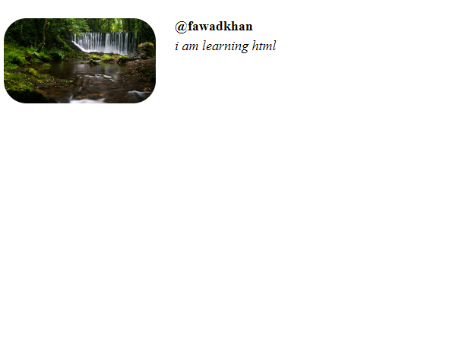

Dev tools use:

Inspect elements and change element values and get the ideal look you want with live changing happening on screen and then copy values and paste it in css(style) code you wrote

Validation of html code is done through 🡪 <https://validator.w3.org/>

Validation of css code is done through 🡪 https://jigsaw.w3.org/css-validator/

!+tab = at start of html document to get html boiler plate

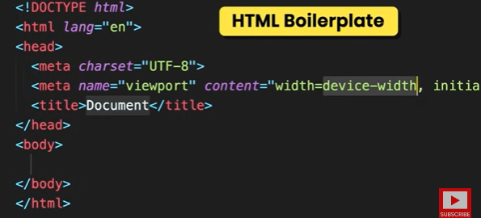

Utf8 is character set in which characters(non numbers) are represented in binary form. Another example of character set is ASCII code.

Working with text:

Abbreviations(customizable in style(css) )

em🡪 emphasize on

i 🡪 italic(don’t use because styling in css)

b 🡪 bold(don’t use because styling in css)

strong 🡪 strong importance

wrap with abbreviation command 🡪wrap selected with an abbreviation for example with em

Always use Heading hierarchy and there should be only one h1 heading for better search engine optimization (change size of heading in css if you want to modify it)

Entities:

If we want to output anything that has some purpose in html or css we write it instead of round brackets below

& () ;

&lt; 🡪 <

&gt; 🡪 >

&nbsp;🡪 none breaking space (give normal space between two words but both words would be on the same line i.e line will not end at the space between the two words in which it is placed)



&copy; 🡪 

Full list of entities is in below link:

https://html.spec.whatwg.org/multipage/named-characters.html

Code:

 <p>lorem10</p>

Output:

Will generate 10 words



Link: Target location i.e the url of destination

Hyperlink: What to click(photo,string,whatever it may be) to go to the link(Destination)